Zevere User Stories

Please see the video report for the user stories workshop in our shared drive COMP 231 001 - Team 3 > Documents > 02 - User Stories: [Team 3 - low fidelity prototype and estimating user stories video](https://drive.google.com/file/d/1NffNKgzwCVIepAre5HMix0PDkfKUJrui/view?usp=sharing).

This document is the written report for our story-writing workshop in which we created a low-fidelity prototype and estimated user stories by applying the Wide-Band Delphi approach.

# Low-Fidelity Prototype

Show below is the our low-fidelity prototype generated from our story-writing workshop. Please [click on this link to see a larger version](https://docs.google.com/drawings/d/11U4jtqGME6VFhHHnrron8WFO-8anjMohDg1b5SODv-8/edit?usp=sharing).

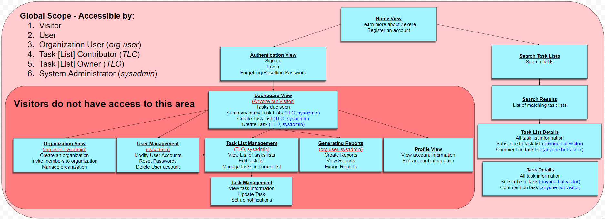

##### Figure 1: Low-Fidelity prototype for our Zevere application.

We have generated one low-fidelity prototype for all of the user roles instead of a separate one for each user role. This is because the different user roles have many user stories in common so we decided one prototype would depict a better representation of our system. There are a few things to note in our low-fidelity prototype. User roles denoted (like this) indicate that the current node and the subtree below it are only accessible by the user roles contained within the parentheses. User roles denoted (like this) indicate that the specific action beside it is only accessible by the user roles contained within the parentheses.

# Index Cards

Shown below are the user story index cards we created during the story-writing workshop. They are divided in the middle to represent the separation between the front and the back of the index card. Please note that as with our low-fidelity prototype, we have combined a number of our user stories together on the same index card to better illustrate the user stories for our Zevere system.

## User Stories for all User Roles:

|  |  |
| --- | --- |
| As a **Visitor/User/Organization User/Task List Contributor/Task List Owner/System Administrator**, I can see Home view of the application after I start the application to either: (i) learn more about Zevere, (ii) sign up as a user of Zevere, (iii) login, or (iv) search for task lists.  Note: UI and accessibility will take time to develop  Estimate: 9 hours | Test by visiting Zevere.  Expected outcome: the system should display core features and user manual about Zevere to the user.  Test by trying to register for an account.  Expected outcome: the system should redirect the user to the authentication view. |

|  |  |
| --- | --- |
| As a **Visitor**, I can perform keyword task searches on task lists that are declared to be public.  As a **User/Organization User/Task List Contributor/Task List Owner/System Administrator**, I can perform keyword task searches on task lists that are either declared to be public or are assigned to me.  Note: We will have many different options for searching i.e. filters, keywords, etc. (need to spend some time deciding on these things)  Estimate: 18 hours | Test by searching for task lists as a visitor.  Expected outcome: the system should only return resulting task lists which are declared to be public.  Test by searching for task lists as a user.  Expected outcome: the system should return resulting task lists which are either declared to be public or are assigned to the authenticated user. |

|  |  |
| --- | --- |
| As a **Visitor**, I can see the public task lists which match the search filters I submitted the query with.  As a **User/Organization User/Task List Contributor/Task List Owner/System Administrator**, I can see the task lists which match the search filters I submitted the query with.  Note: UI => Search Task Lists and Search Results may be the same view.  Estimate: 4 hours | Test by clicking on a task list from the query results.  Expected outcome: the system should redirect the user to another view which displays the details of that task list. |

|  |  |
| --- | --- |
| As a **Visitor**, I view the details of each public task list.    As a **User/Organization User/Task List Contributor/Task List Owner/System Administrator**, I can either (i) view the details of task lists assigned to me or public task lists, (ii)subscribe to the task list, or (iii) add comments to the task list.  Note: Task List Details is more of a “read-only” view with the addition of ability to “comment” on the task list.  Note: Gathering the data to display from persistent storage won’t be too much of a problem, but UI design will take long time.  Estimate: 7 hours | Test by adding a comment to a task list.  Expected outcome: the system should propagate this comment across the system and retain it in persistent storage.  Test by logging into to one account and leaving a comment, and then logging into a second account to view the task list.  Expected outcome: the second user account is able to see the comments left on the same task list by the first user account. |

|  |  |
| --- | --- |
| As a **Visitor**, I view the details of each public task.  As a **User/Organization User/Task List Contributor/Task List Owner/System Administrator**, I can either (i) view the details of tasks assigned to me or public tasks, (ii)subscribe to the task, or (iii) add comments to the task.  Note: Task Details is more of a “read-only” view with the addition of ability to “comment” on the task.  Note: Gathering the data to display from persistent storage won’t be too much of a problem, but UI design will take long time.  Estimate: 7 hours | Test by adding a comment to a task.  Expected outcome: the system should propagate this comment across the system and retain it in persistent storage.  Test by logging into to one account and leaving a comment, and then logging into a second account to view the task.  Expected outcome: the second user account is able to see the comments left on the same task by the first user account. |

|  |  |
| --- | --- |
| As a **Visitor/User/Organization User/Task List Contributor/Task List Owner/System Administrator**, I can either: (i) sign up for a new account, (ii) login to my account using my username and password, or (iii) request to reset my password for my existing account.  Estimate: 4 hours | Test by requesting to reset password for an existing account.  Expected outcome: the system will send an email to the registered email associated with that account providing a link and instructions to reset password.  Test by logging in to an account with valid credentials.  Expected outcome: the system should redirect the user to their dashboard. |

## User Stories for Registered Users:

|  |  |
| --- | --- |
| As a **User/Organization User/Task List Contributor**, I can visit my Dashboard and see tasks [Lists] which are due soon.  As a **Task List Owner/System Administrator**, I can visit my Dashboard and either: (i) see task(s) [List(s)] which are due soon, (ii) view my task lists, or (iii) create new task [lists].  Note: look at low-fidelity prototype...this is our core component in our system...this one will take a long time, especially since we need it to integrate with every other component  Note: need to determine how to display task [list]s due soon...reminders? Pop Ups, notifications or something else entirely?  Note: For UI -> summary of my task lists can be collapsable panels  Estimate: 35 hours | Test by modifying the due date of a task [list] to be within the next 7 days.  Expected outcome: the system will display this task [list] on the dashboard view with reminders.  Test by creating a new task list  Expected outcome: the system will redirect the view to the Task List Management view.  Test by creating a new task.  Expected outcome: the system will place this task in the authenticated user’s default task list, and redirect the view to the Task Management view. |

|  |  |
| --- | --- |
| As a **User/Organization User/Task List Contributor/Task List Owner/System Administrator**, I can view and modify my account details.  Note: account details -> profile picture, username, age, permissions, etc.  Note: lots of validation for each attribute to consider  Estimate: 9 hours | Test by modifying the account information of the authenticated user.  Expected outcome: the system will update the modified account information in persistent storage and this information should be propagated across the system such that it is visible across different views. |

## User Stories for Exclusive User Roles:

|  |  |
| --- | --- |
| As a **Task List Owner/System Administrator**, I can (i) view all tasks lists created by me, (ii) edit my task lists’ details and permissions, (iii) manage permissions regarding my task lists, and (iv) create new tasks under this task list.  Note: Task List is like a “Project”  Note: A task is like a deliverable inside the project  Note: Task list permissions => who authorized to contribute/view (set task list to be public)  Note: A contributor of a task list would be authorized to contribute to any task under the task list.  Note: Task details also includes comments on the task lists  Estimate: 17 hours | Test by changing permissions on the task list.  Expected outcome: the system will update these changes in the persistent storage and propagate them across the system such that contributors of this task list will be impacted by these new permissions.  Test by changing details in the task list.  Expected outcome: the system will update these changes in the persistent storage and propagate them across the system such that users who are able to view this task list in other views see the updated changes. |

|  |  |
| --- | --- |
| As a **Task List Owner/System Administrator**, I can (i) update the status of the task, (ii) set up notifications, and (iii) update the task details.  Note: details => tags, due date, task type, etc.  Estimate: 10 hours | Test by changing details in the task.  Expected outcome: the system will update these changes in the persistent storage and propagate them across the system such that users who are able to view this task in other views see the updated changes.  Test by deleting a task.  Expected outcome: the system will remove any data associated with this task from the persistent storage such that the task and any of its details should not be accessible from any other views of the system. |

|  |  |
| --- | --- |
| As an **Organization User/System Administrator**, I can either (i) create an organization, (ii) invite members to join my existing organization, or (iii) manage my organization’s details.  Note: details => profile, owner, list of members, organization goal, description, etc.  Estimate: 10 hours | Test by inviting a user to join an organization.  Expected outcome: the system should send an in-app notification to the user as well as an email to the email account associated to the registered account (regarding this invitation).  Test by accepting an invitation to join an organization as a contributor.  Expected outcome: the system should display this user as part of the organization’s list of users on this view, as well as sending a notification/email to the organization account. |

|  |  |
| --- | --- |
| As a **System Administrator**, I can either (i) modify user accounts, (ii) reset passwords for users, or (iii) delete user accounts on the Zevere system.  Note: System administrators can modify task lists and their constituents that are owned by other users.  Estimate: 12 hours | Test by modifying a user account’s details.  Expected outcome: the system should propagate these changes in the persistent storage such that the user will be able to see these updated changes when they login to their account. |

|  |  |
| --- | --- |
| As a **System Administrator**, I can either (i) generate reports for the Zevere System, (ii) view generated reports or (iii) export reports to other formats.  Note: reports => user traffic, error logs, etc.  Note: pulling data from many components and doing analysis on the data will take a long time...this will probably be one of our larger components to develop  Estimate: 24 hours | Test by generating a report for user traffic for the past week.  Expected outcome: the system should gather and mould the necessary data to generate the report, and display the report to the screen as well as providing options to export to other formats. |

### 